Assignment Questions

1. Create an automation in UiPath Studio that:
• Opens ReportTemplate.pptm as the main presentation.
• Copies a slide from ReportOutline.pptx and inserts it after the title slide.
• Deletes the first slide titled Instructions from ReportTemplate.pptm.

Objective: To automate the process of merging slides from different PowerPoint files and removing unwanted slides using UiPath Presentation activities.
Step-by-Step Implementation:
- Initialize Main Presentation:
  - Add a Use PowerPoint Presentation activity.
  - File: Select ReportTemplate.pptm.
  - Reference as: ReportTemplatePPT.
  - Configuration: Uncheck 'Save changes' (for testing) or check it to save results. Uncheck 'Create if not exists'.
- Initialize Source Presentation (Nested):
  - Inside the body of the first activity, add another Use PowerPoint Presentation.
  - File: Select ReportOutline.pptx.
  - Reference as: ReportOutlinePPT.
- Copy and Paste Slide:
  - Inside the inner scope, add a Copy Paste Slide activity.
  - Source Presentation: ReportOutlinePPT.
  - Slide to Copy: 1 (The first slide).
  - Destination Presentation: ReportTemplatePPT.
  - Where to Insert: 2 (To place it after the Title slide, which is usually slide 1, but since we will delete slide 1 later, inserting at index 2 or 3 depends on the current structure. Based on the textbook example, inserting at position 3 places it after the title).
- Delete Slide:
  - Add a Delete Slide activity inside the main scope.
  - Presentation: ReportTemplatePPT.
  - Slide Number: 1 (To remove the "Instructions" slide).

Configuration Diagram:
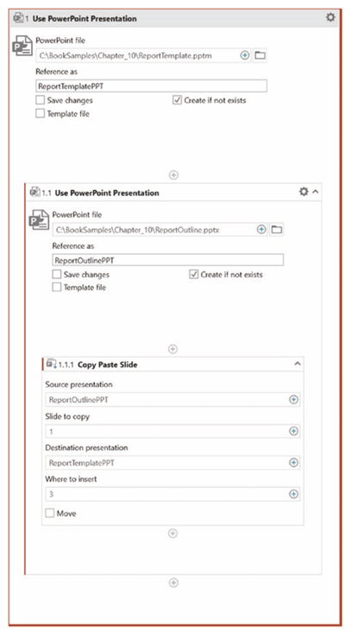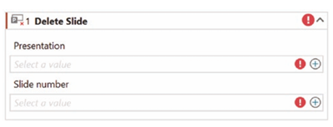

2. Demonstrate the step-by-step process to configure and use the “Use Excel File” activity in UiPath Studio.
Illustrate your answer with an example scenario of automating employee data from the EmployeeOnboarding.xlsx file.
Answer:
Objective: To set up the foundation for Excel automation by defining the scope using the "Use Excel File" activity.
Concept: The Use Excel File activity (found under Resources) creates a link between UiPath and a specific Excel workbook. It acts as a container/parent activity for all other Excel actions (like Read Range, Write Cell, etc.).
Step-by-Step Configuration:
- Add Activity: Drag and drop the Use Excel File activity into your sequence.
- Select File: Click the Folder icon next to the "Excel file" field.
  - Navigate to and select: C:\BookSamples\Chapter_07\EmployeeOnboarding.xlsx.
- Reference As: In the "Reference as" field, enter a descriptive name.
  - Value: EmployeeOnboarding (This name allows you to easily reference this specific file in child activities).
- Save Changes: Ensure the "Save changes" checkbox is checked. This ensures data written by the bot is persisted.
- Create if not exists: Ensure "Create if not exists" is checked (creates the file if it's missing).
Example Scenario Configuration: In the Employee Onboarding scenario, this activity allows the HR bot to open the master employee list to eventually add new hires or update statuses.

Configuration Diagram:
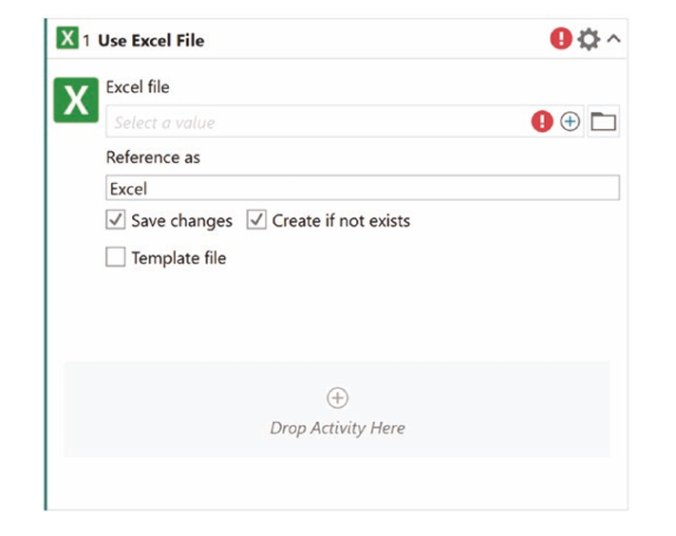

3. Develop a UiPath Studio workflow that:
• Checks whether a folder named with the current date (YYYYMMDD) exists in C:\BookSamples\Chapter_09\Resumes.
• If it doesn’t exist, creates the folder dynamically.
• Copies all contents from the Templates folder into the newly created date folder.
• Moves the folder 20200909 from Resumes to the Archive directory.
Answer:
Objective: To manage daily file organization by dynamically creating dated folders and archiving old data.
Step-by-Step Implementation:
- Check Folder Existence:
  - Add a Folder Exists activity.
  - Folder Path: C:\BookSamples\Chapter_09\Resumes\ + [Project Notebook] Date!YYYYMMDD (Dynamic path).
  - Save Result: Save to a variable, e.g., FolderExists.
- Conditional Logic (If):
  - Add an If activity.
  - Condition: FolderExists is False.
- Create Folder (Then Block):
  - Add Create Folder activity.
  - Folder Name: Same dynamic path as step 1.
- Copy Template Content (Then Block):
  - Add Copy Folder activity.
  - From: C:\BookSamples\Chapter_09\Templates.
  - To: The newly created dynamic date folder.
  - Options: Check Include subfolders.
- Archive Old Folder (Outside If):
  - Add Move Folder activity.
  - From: C:\BookSamples\Chapter_09\Resumes\20200909.
  - To: C:\BookSamples\Chapter_09\Archive.

Configuration Diagram:
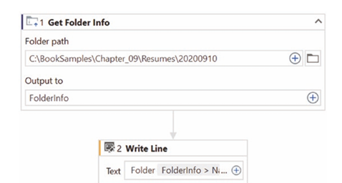
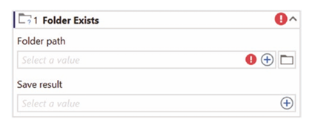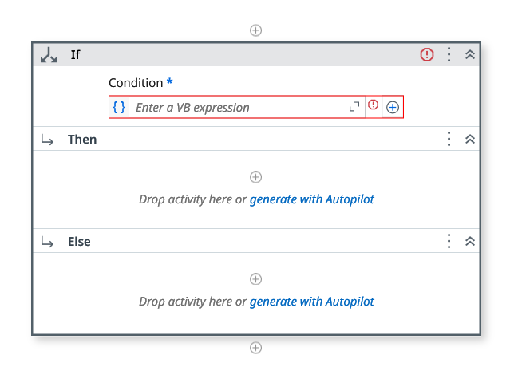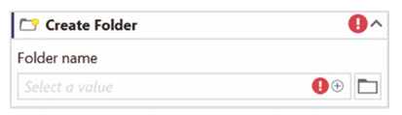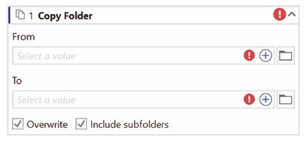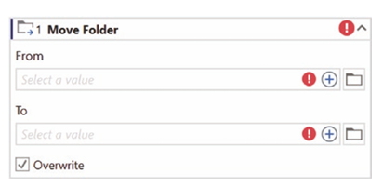

4. Use the “Get Folder Info” activity in UiPath Studio to extract folder properties for
C:\BookSamples\Chapter_09\Resumes\20200910
and display the folder’s name and last modified date in the Output panel.
Answer:
Objective: To retrieve metadata (properties) of a directory for auditing or logic purposes.
Step-by-Step Configuration:
- Add Activity: Drag the Get Folder Info activity into the designer.
- Configure Path:
  - Folder Path: C:\BookSamples\Chapter_09\Resumes\20200910
- Save Output:
  - Output to: Click the plus icon and select "Save for Later Use". Name the variable FolderInfo.
- Display Output:
  - Add a Write Line activity.
  - Text: Use the text builder to combine: "Folder Name: " + FolderInfo.Name + " | Last Modified: " + FolderInfo.LastModifiedDate
Configuration Diagram:

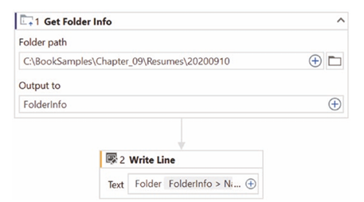

5. Create a UiPath Studio automation process that performs the following:
• Adds two new rows at a specific index in the New Hires List sheet.
• Deletes the newly added rows.
• Finds the last data row in the New Hire Checklist sheet and displays the result in the Output panel.
Describe the logic and configurations used for each activity involved in this workflow.
Answer:
Objective: To manipulate Excel rows (Insert/Delete) and dynamically locate data boundaries.
Step-by-Step Implementation & Logic:
- Scope: Use Use Excel File pointing to EmployeeOnboarding.xlsx.
- Insert Rows:
  - Activity: Insert Rows.
  - Table/Range: [EmployeeOnboarding] New Hires List.
  - Num Rows: 2.
  - Where: Select Specific Index.
  - Row Number: 5 (Inserts rows at index 5).
  - Logic: Shifts existing data down to make space.
- Delete Rows:
  - Activity: Delete Rows.
  - Table/Range: [EmployeeOnboarding] New Hires List.
  - What to Delete: Specific rows.
  - At Position: 5-6 (or just 5, 6 to remove the ones just added).
  - Logic: Removes the blank rows to restore the original state.
- Find Last Row:
  - Activity: Find First/Last Data Row.
  - Source: [EmployeeOnboarding] New Hire Checklist.
  - Column Name: ID (or Column A).
  - Save Last Row Number as: Save to a variable, e.g., LastRowNum.
  - Logic: Scans the specific column to find the last used cell index.
- Display Result:
  - Activity: Write Line.
  - Text: LastRowNum variable.

Configuration Diagram:
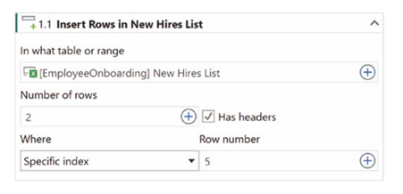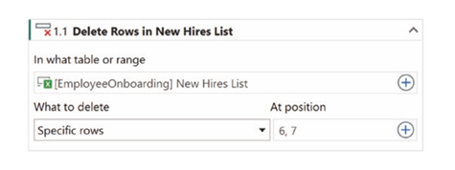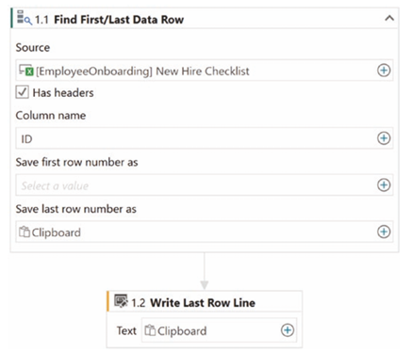
6. Build a UiPath Studio process to automate slide modification in ReportTemplate.pptm:
Add three new slides using the Title and Content layout.
• Replace the text <REPORTDATE> on the title slide with the current system date.
• Update slide titles as follows:
• Slide 3 → Top Trending Products List
• Slide 4 → Trend Chart
• Slide 5 → Source Data List
Answer:
Objective: To customize a presentation template by adding structure and dynamic text.
Step-by-Step Implementation:
- Scope: Add Use PowerPoint Presentation referencing ReportTemplate.pptm.
- Add Slides:
  - Add Add New Slide activity (Repeat 3 times).
  - Layout: Select Title and Content.
  - Add As: Last Slide.
  - Save Slide Number As: Save as variables (e.g., Slide3Num, Slide4Num, Slide5Num) if needed for reference, though here we know they are 3, 4, and 5.
- Replace Date:
  - Add Replace Text in Presentation.
  - Find What: <REPORTDATE>.
  - Replace With: Select Notebook -> Date -> Today (or System.DateTime.Now.ToString("yyyy-MM-dd")).
- Update Titles:
  - Add Add Text to Slide (Repeat 3 times).
  - Slide 3: Slide Number=3, Placeholder=Title 1, Text=Top Trending Products List.
  - Slide 4: Slide Number=4, Placeholder=Title 1, Text=Trend Chart.
  - Slide 5: Slide Number=5, Placeholder=Title 1, Text=Source Data List.
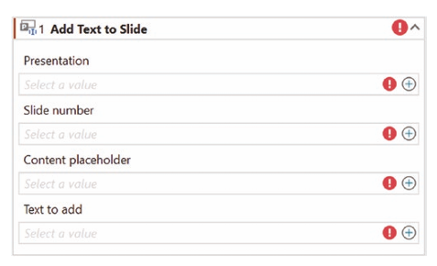
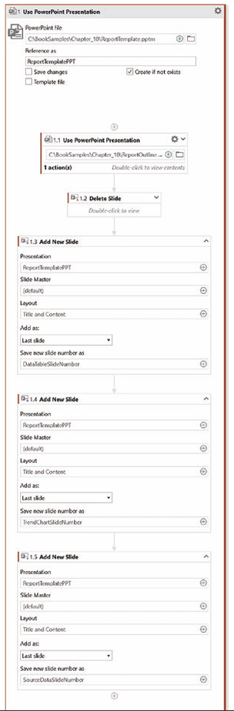
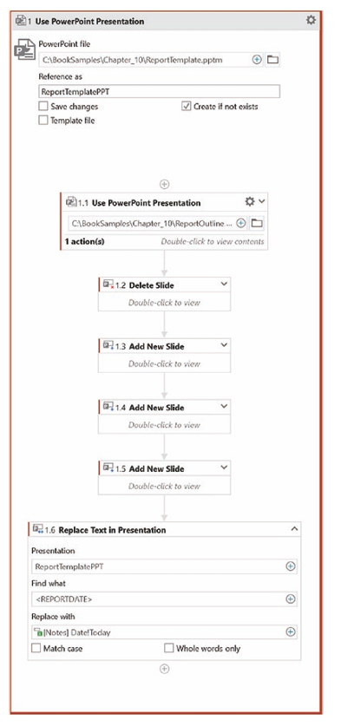
Configuration Diagram:

7. Demonstrate how the “Insert Column” and “Text to Columns” activities can be combined in an Excel automation process to split full names into first and last names for employee records.
Use an example from the New Hires List sheet to support your answer.
Answer:
Objective: To parse data (Full Name) into separate accessible columns (First/Last Name).
Step-by-Step Configuration:
- Context: Assume column B is "Full Name". We need columns C and D for "Last Name" and "First Name".
- Insert Columns:
  - Use Insert Column activity.
  - Range: New Hires List.
  - Where: After.
  - Relative to: Full Name.
  - Add Header: Last Name.
  - Repeat activity to add First Name column after Last Name.
- Text to Columns:
  - Use Text to Columns activity.
  - Source: Select the range containing the full names (e.g., B2:B21).
  - Destination: Select the range for the new columns (e.g., C2:D21).
  - Delimiters: Check Comma and Space (Assuming format is "Last, First").
  - Logic: This activity parses the string in the source cell based on the delimiter and pushes the parts into the destination columns.

Configuration Diagram:
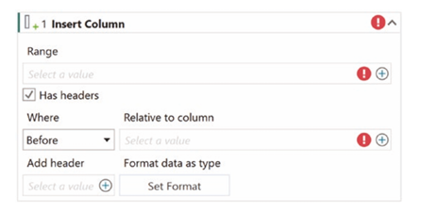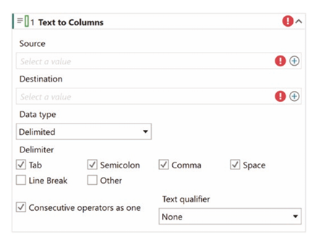

8. Build a UiPath workflow to automate the following process using Word activities:
i. Replaces the existing placeholder image in the document with the actual student’s profile picture (StudentPhoto.jpg).
ii. Adds the school logo (SchoolLogo.png) at the bottom of the document, after all content.
Answer:
Objective: To dynamically update images within a Word document report.
Step-by-Step Implementation:
- Scope: Add Use Word File activity. Select the student report document.
- Replace Placeholder Image:
  - Add Replace Picture activity.
  - Find pictures with Alt Text: Enter the Alt Text of the placeholder image (e.g., StudentPlaceholder). Note: The template must have Alt Text set on the image.
  - Replace with: Select StudentPhoto.jpg.
- Add Logo:
  - Add Add Picture activity.
  - Picture to Insert: Select SchoolLogo.png.
  - Insert Relative To: End of Document (This ensures it appears at the bottom after all content).
Configuration Diagram:

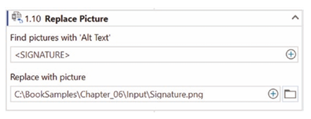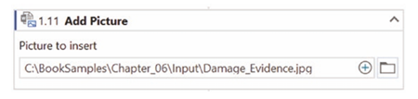

9. Design an automation workflow that performs the following tasks using UiPath Studio:
• Inserts a new sheet called “New Data” into an existing workbook.
• Renames the sheet to “New Hire Statistics.”
• Duplicates an existing sheet “New Hire Salaries” and renames it to “Salaries Copy.”
Describe the configuration settings used in your workflow.
Answer:
Objective: To programmatically manage Excel worksheets (CRUD operations on sheets).
Step-by-Step Configuration:
- Scope: Use Excel File (EmployeeOnboarding.xlsx).
- Insert Sheet:
  - Activity: Insert Sheet.
  - Sheet Name: New Data.
  - Create in Workbook: [EmployeeOnboarding].
- Rename Sheet:
  - Activity: Rename Sheet.
  - From: Select New Data.
  - To: Type New Hire Statistics.
- Duplicate Sheet:
  - Activity: Duplicate Sheet.
  - Sheet to Duplicate: Select New Hire Salaries.
  - Rename to: Type Salaries Copy.
Configuration Diagram:
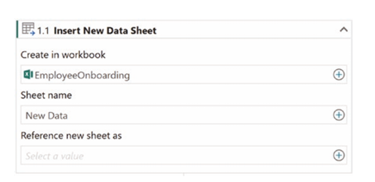
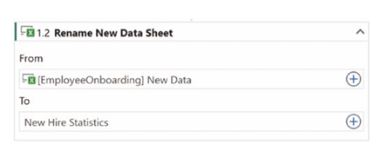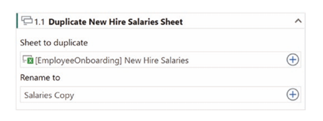

10. Develop a Word automation workflow for a classroom student report that:
• Reads text from the document.
• Replaces outdated student information or marks.
• Appends teacher remarks at the end.
• Updates comments at a predefined Bookmark.
Implement the workflow using the given activities.
Answer:
Objective: To perform text extraction, replacement, and insertion using Word activities.
Step-by-Step Implementation:
- Scope: Use Word File referencing the Student Report.
- Read Text:
  - Activity: Read Text.
  - Save to: Save to a variable (e.g., DocContent) if analysis is needed, or Clipboard.
- Replace Information:
  - Activity: Replace Text in Document.
  - Search for: <OLD_MARKS> (Placeholder text).
  - Replace with: 95 (New value).
  - Replace all: True.
- Append Remarks:
  - Activity: Append Text.
  - Text: "Teacher Remark: Excellent performance this semester."
  - Add new line before: True.
- Update Bookmark:
  - Activity: Set Bookmark Content.
  - Bookmark Name: TeacherComments (Must exist in the Word template).
  - Text: "Keep up the hard work."
Configuration Diagram:

